Practical No. 9
Aim : Use Interface to implement the concept of Multiple Inheritance
Name : Danish Altaf Solkar | Class : CO - B
Enrolment no. : 24111590805 | Batch : 2
Code :-
interface Salary
{
float basic_salary = 450000;
public void basic_sal();
}
class Employee
{
String name = "Danish";
float age = 24;
public void display()
{
System.out.println("Name : "+name);
System.out.println("Age : "+age);
}
}
class gross_salary extends Employee implements Salary
{
float TA = (basic_salary*8)/100;
float DA = (basic_salary*2)/100;
float HRA = (basic_salary*5)/100;
public void basic_sal()
{
System.out.println("Basic Salary : "+basic_salary);
}
public void Total_sal()
{
float total_salary = basic_salary + TA + DA + HRA;
System.out.println("Total Salary : "+total_salary);
}
public static void main(String [] args)
{
gross_salary g = new gross_salary();
g.display();
g.basic_sal();
g.Total_sal();
}
}
OUTPUT :-
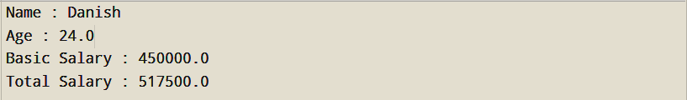

Practical No. 9
Aim : Develop a program to find Area of Rectangle and Circle using Interfaces
Name : Danish Altaf Solkar | Class : CO - B
Enrolment no. : 24111590805 | Batch : 2
Code :-
interface rectangle
{
float length = 10;
float breadth = 20;
void rect_area();
}
interface circle extends rectangle
{
float pi = 3.14f;
float radius = 20f;
void circle_area();
}
class multilevel implements circle
{
public void rect_area()
{
float a = length*breadth;
System.out.println("Area of rectangle : "+a);
}
public void circle_area()
{
float b = pi*radius*radius;
System.out.println("Area of circle : "+b);
}
public static void main(String [] args)
{
multilevel m = new multilevel();
m.rect_area();
m.circle_area();
}
}
OUTPUT :-
Process related  (35) | Product related  (15) | Total Marks  (50) | Signature

